Unit-1:
- Write code demonstrating variables holding different data types: string, integer, float, Boolean.
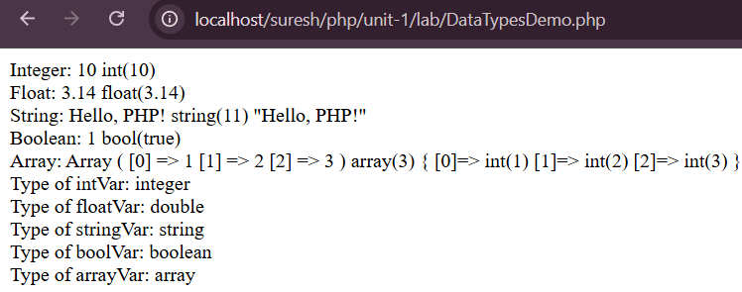
- Show different ways to declare and initialize variables in PHP.
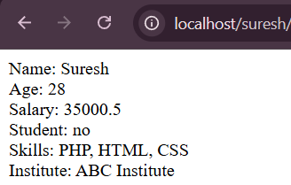
- Write expressions using various mathematical, comparison, and logical operators in PHP.
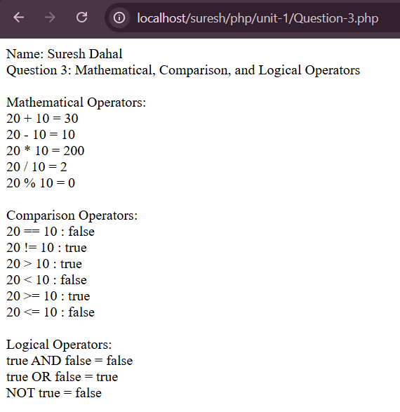

- Write code demonstrating loop controls like for, while, and do-while loops in PHP.
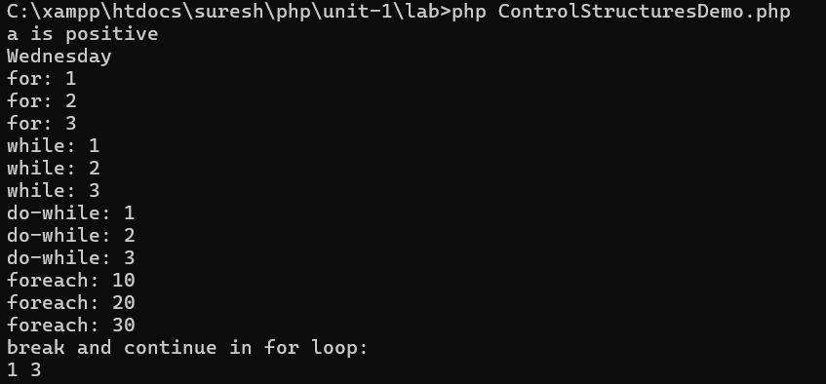
- Demonstrate including external PHP files using require and include statements.
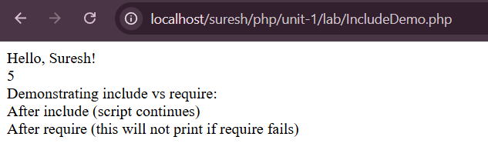
- WAP to demonstrate embedding PHP directly in HTML page.
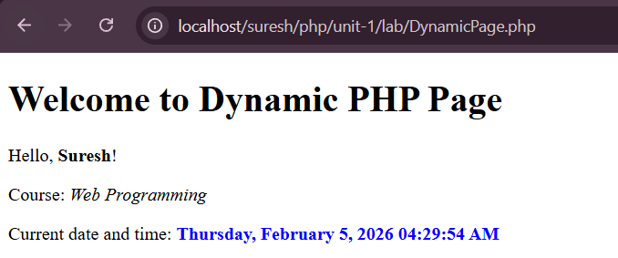

Unit-2:
- Write a function that receives a string and checks if it's a palindrome (reads the same backward) in PHP
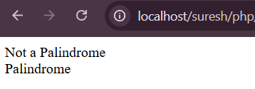
- Demonstrate how to call a function within another function in PHP.
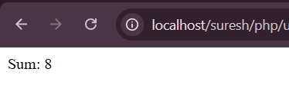
- How can you access a global variable from within a function in PHP, Write the program.
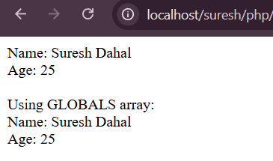
- Write a function that swaps the values of two variables using parameter references in PHP.
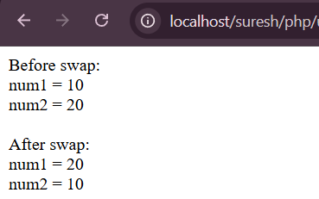
- Write a function that calculates the area of a circle and returns the result in PHP.
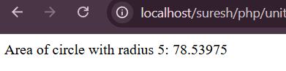
- Write an anonymous function that checks if a string is empty in PHP.
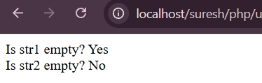

- Generate the current date and time in different formats using PHP functions.
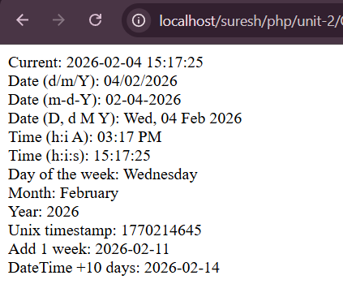

Unit-3:
- Demonstrate different ways to print a string in PHP.
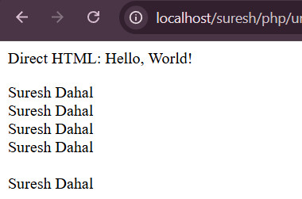
- WAP to access individual characters in a string in PHP.
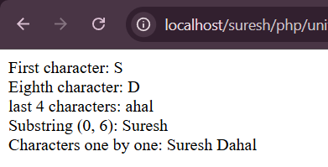
- WAP to remove whitespace from the beginning and end of a string in PHP.
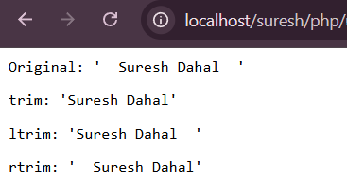
- WAP to use the functions which are used for HTML and URL encoding in PHP.
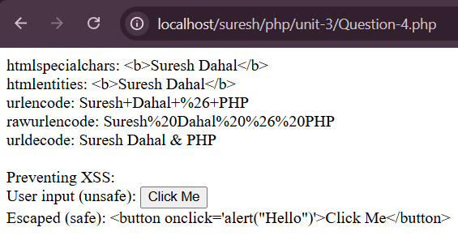
- WAP to prevent SQL injection by escaping strings in PHP.
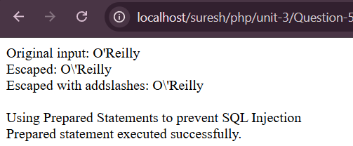
- Demonstrate various methods for comparing two strings in PHP.
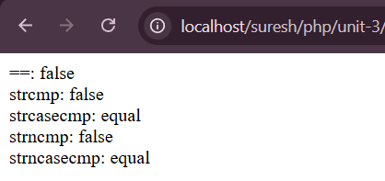
- WAP to use string manipulation functions like strlen, substr, and str_replace in PHP.
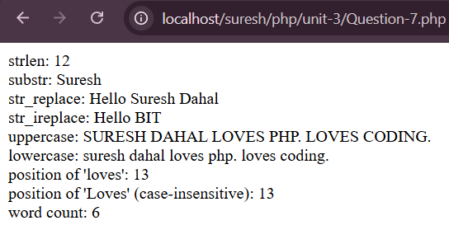
- WAP to use strpos and stristr functions for searching within strings in PHP.
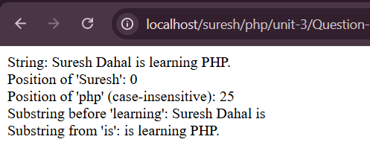
- WAP to use regular expressions in PHP for pattern matching in strings.
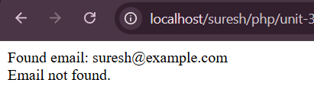
- WAP to create an array and access its elements in PHP.
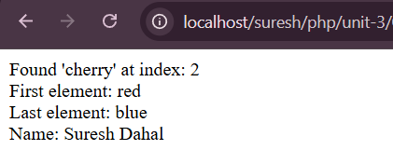

- WAP to add elements to an indexed array dynamically in PHP.
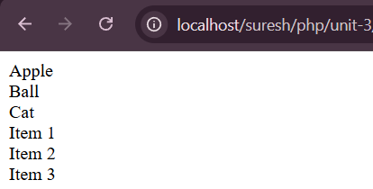
- WAP to create and access elements in an associative array in PHP.
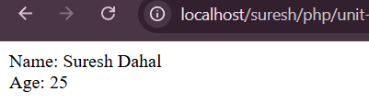
- WAP to use an array to store user details (name, age, email) in PHP.
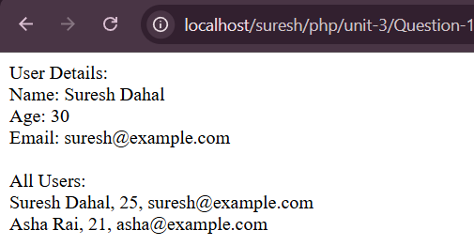
- WAP to create and manipulate a two-dimensional array in PHP.
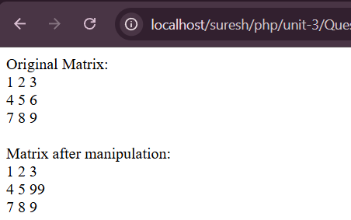
- WAP to extract multiple values from an array in PHP.
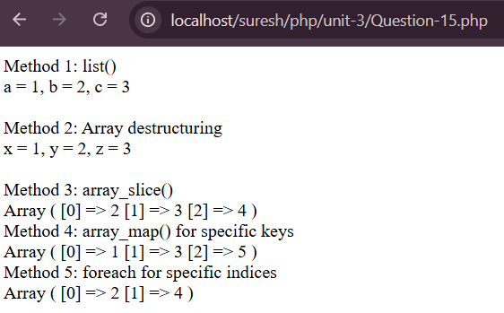

- WAP to convert a variable to an array and vice-versa in PHP.
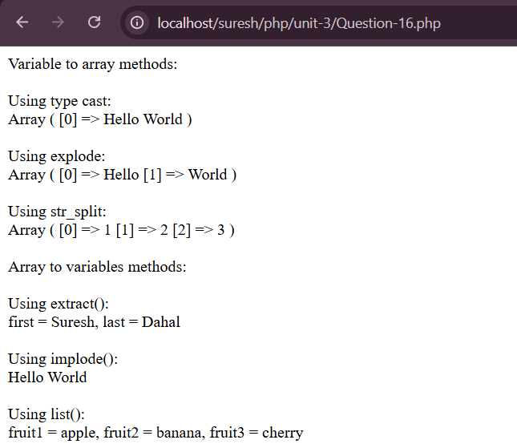
- WAP to use loops to traverse both indexed and associative arrays in PHP.
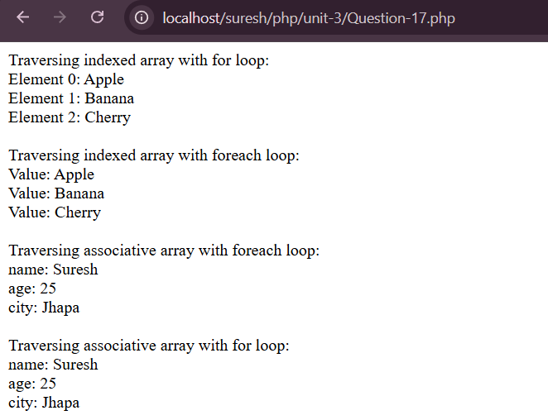

Unit-4:
- Write PHP code to create an object of a class named "Book" with properties like title,
author, and publication year.
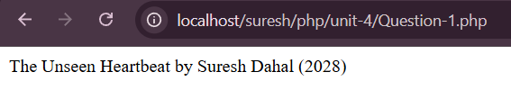
- Demonstrate how to access the properties of an object in PHP. Include examples of both public and private properties.
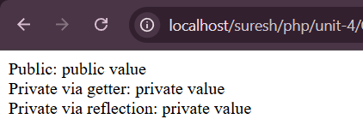
- Write a PHP class declaration for a "Person" class with attributes like name, age, and
address.
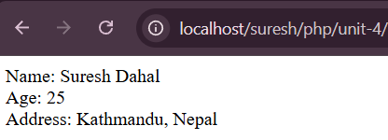
- Write a PHP program which uses a class with a constructor.
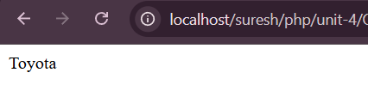
- Write a PHP program which uses an anonymous class.
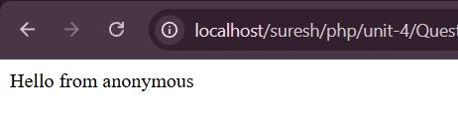
- How can reflection be used in PHP to examine and manipulate classes and objects? WAP to demonstrate the given concept.
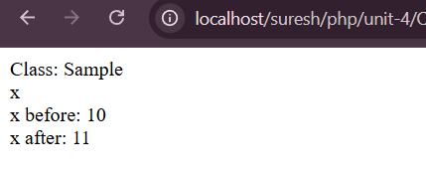

Unit-5:
- WAP to perform “action" and "method" attributes in an HTML form. How are they
utilized in PHP form processing?
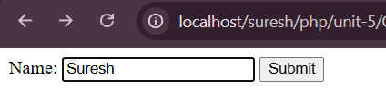
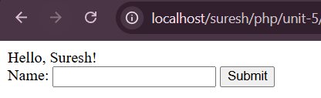

- Implement a form in PHP that includes various input types such as text, radio buttons,
checkboxes, and a select dropdown.
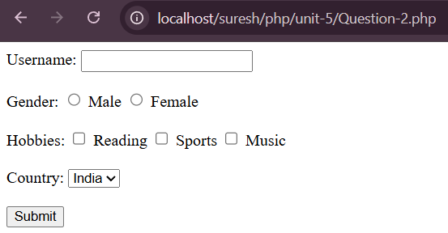
- Demonstrate how to access individual form field values submitted through a POST/GET request in PHP.
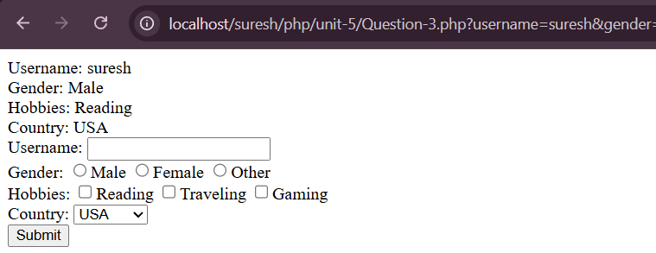
- Write PHP code to validate form input for a registration form, checking for empty fields, valid email addresses, and secure passwords.
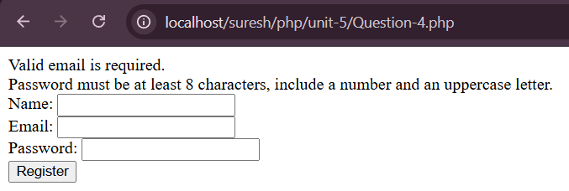
- Write PHP code to set a custom response header, such as "Content-Type" or "Location," in order to control the behavior of the client browser.
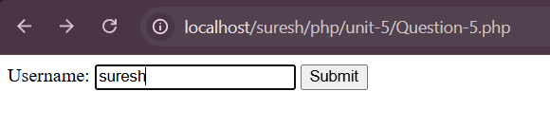
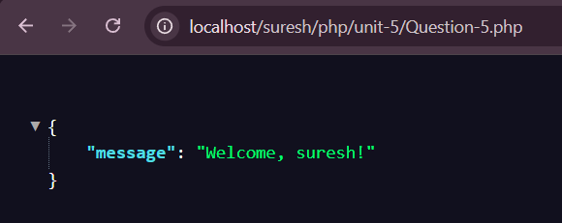

Unit-6:
- WAP to provide the steps involved in connecting to a MySQL database using PHP.
Provide a code using mysqli and PDO extensions.
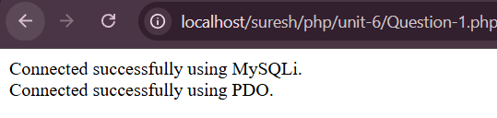
- Create an HTML form for a simple "Product" database table, including fields for product name, description, price, and quantity. Implement CRUD operations.
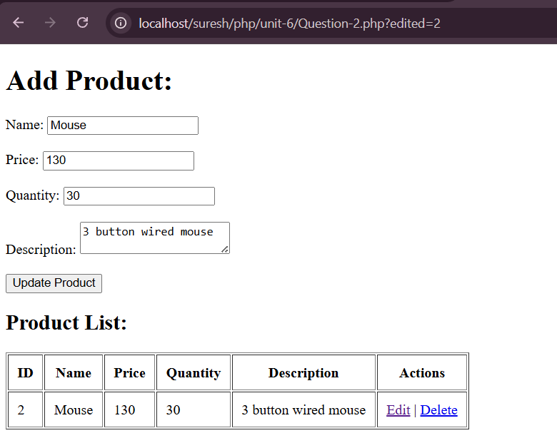

Unit-7:
- Create a PHP script that sets a cookie with a user's preferences, such as language or
theme. Retrieve and use this cookie in subsequent visits.
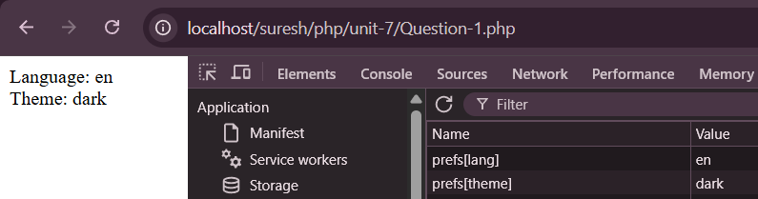
- Write PHP code to delete a cookie on the client-side and explain the implications of
doing so.
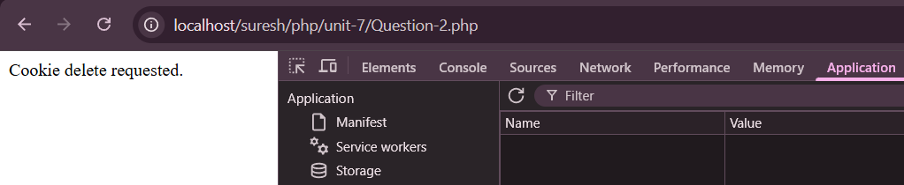
- Implement HTTP Basic Authentication in PHP for a protected area of a website.
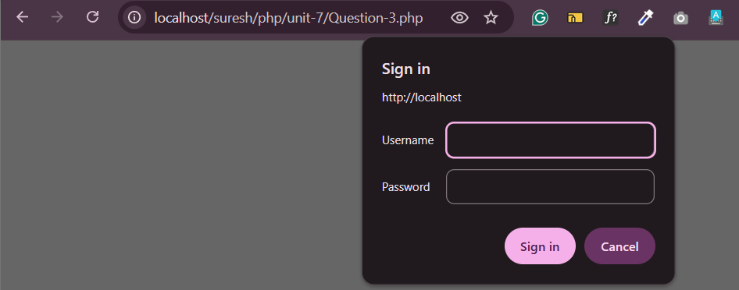
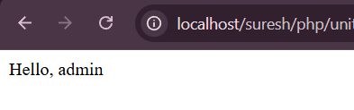
- How can you secure an API using token-based authentication in PHP? Provide a step-by-step explanation with PHP code.
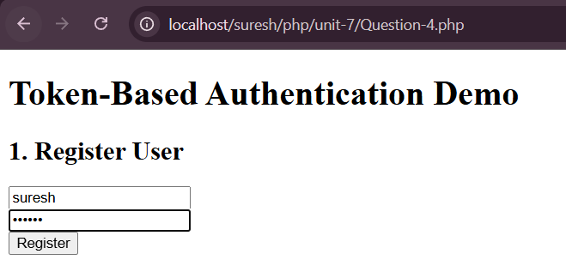
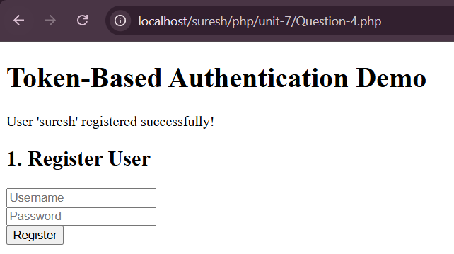

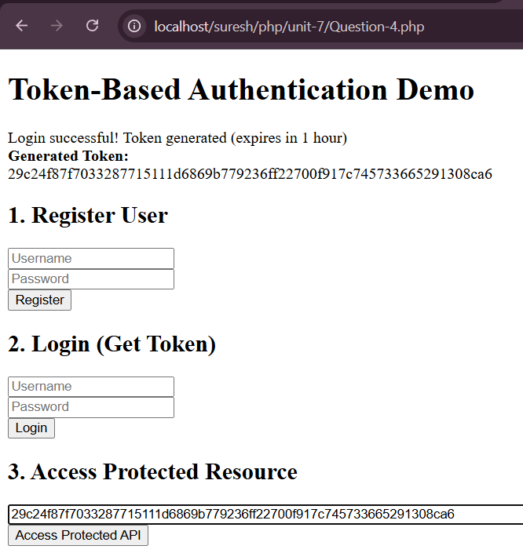

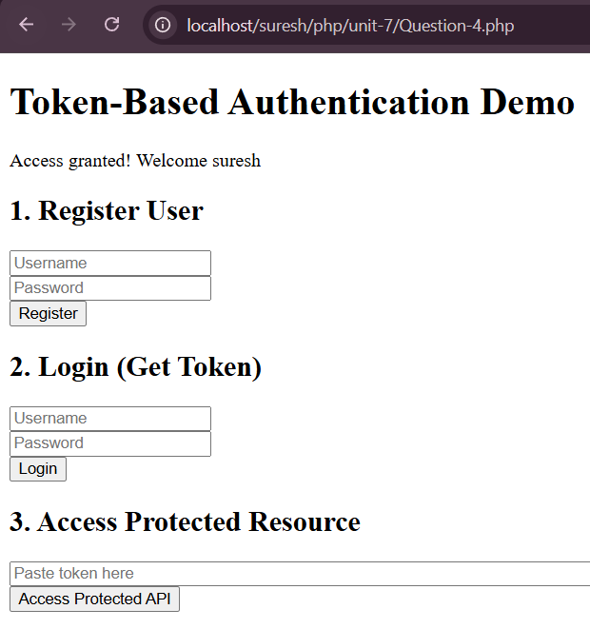

- Create a simple login system using PHP sessions. Include functionality for login, logout, and checking if a user is authenticated.
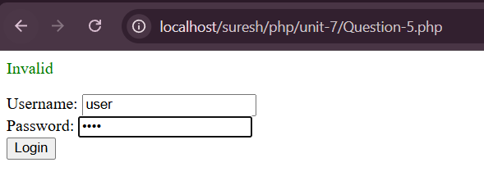
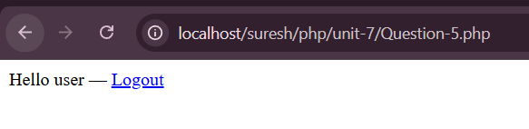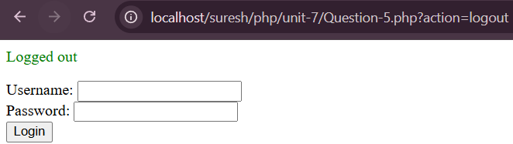

Unit-8:
- WAP to use php.ini file in PHP configuration program.
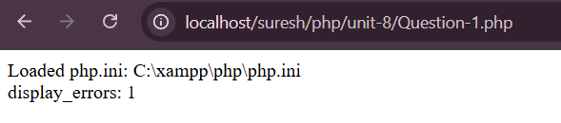
- WAP to use E_ERROR and E_WARNING error types in PHP.
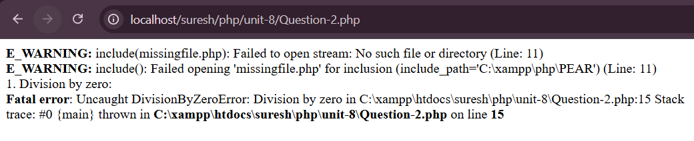
- WAP to use a try-catch block to handle exceptions in PHP.
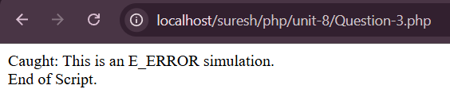
- WAP to use @ symbol before a function call in PHP.
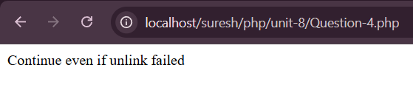
- WAP to trigger a custom error condition using the trigger_error() function.
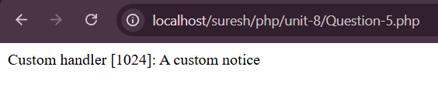
- WAP to configure PHP to log errors to a file.
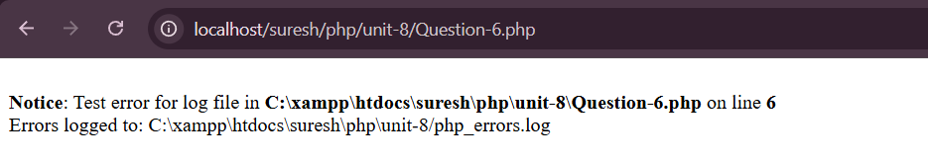

Unit-9:
- Demonstrate how to open a file for writing in PHP using fopen() and write a simple
string to it.
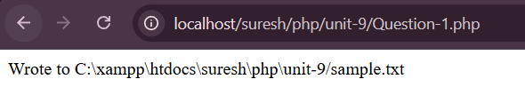
- WAP to read the entire contents of a text file into a string variable in PHP.
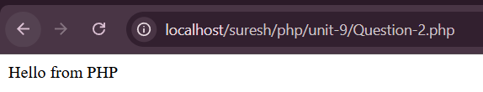
- WAP to use $_FILES superglobal in handling file uploads in PHP.
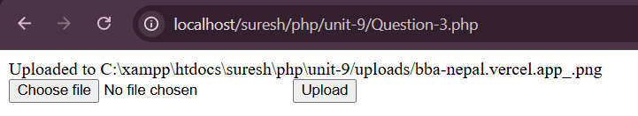
- WAP to read and parse a CSV file in PHP.
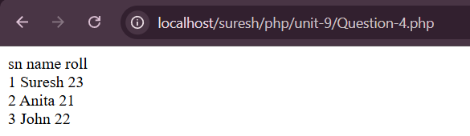
- WAP to read and parse a JSON file in PHP.
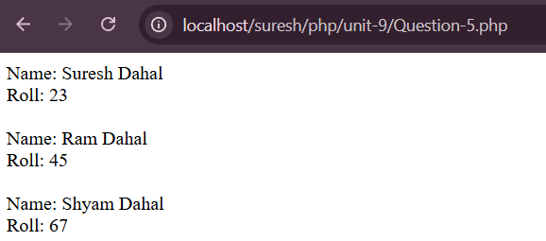

LAB-2: Create an HTML form for a simple "Product" database table, including fields for product name, description, price, and quantity. Implement CRUD operations.
<?php
$db = new mysqli('localhost', 'root', '', 'inventory');
if($db->connect_error)
die("Connection failed: " . $db->connect_error);
if(isset($_POST['add'])){
$name = $_POST['name'] ?? '';
$price = floatval($_POST['price'] ?? 0);
$quantity = intval($_POST['quantity'] ?? 0);
$description = $_POST['description'] ?? '';
$stmt = $db->prepare("INSERT INTO products (name, price, quantity, description) VALUES (?, ?, ?, ?)");

if($stmt){
$stmt->bind_param("sdis", $name, $price, $quantity, $description);
if($stmt->execute()){
echo "Product added successfully.";
} else
echo "Error: " . $stmt->error;
$stmt->close();
} else {
echo "Error preparing statement: " . $db->error;
}

header("Location: $_SERVER[PHP_SELF]");
exit();
}

if(isset($_GET['deleted'])){
$id = intval($_GET['deleted']);
$stmt = $db->prepare("DELETE FROM products WHERE id = ?");
if($stmt){
$stmt->bind_param("i", $id);
if($stmt->execute()){
echo "Product deleted successfully.";
} else {
echo "Error: " . $stmt->error;
}
$stmt->close();
} else {
echo "Error preparing statement: " . $db->error;
}
header("Location: $_SERVER[PHP_SELF]");
exit();
}

if(isset($_POST['update'])){
$id = intval($_POST['id'] ?? 0);
$name = $_POST['name'] ?? '';
$price = floatval($_POST['price'] ?? 0);
$quantity = intval($_POST['quantity'] ?? 0);
$description = $_POST['description'] ?? '';

$stmt = $db->prepare("UPDATE products SET name = ?, price = ?, quantity = ?, description = ? WHERE id = ?");
if($stmt){
$stmt->bind_param("sdisi", $name, $price, $quantity, $description, $id);
if($stmt->execute()){
echo "Product updated successfully.";
} else {
echo "Error: " . $stmt->error;
}
$stmt->close();
} else {
echo "Error preparing statement: " . $db->error;
}
header("Location: $_SERVER[PHP_SELF]");
exit();
}
$edit = null;
if(isset($_GET['edited'])){
$eid = intval($_GET['edited']);
$stmt = $db->prepare("SELECT * FROM products WHERE id = ?");
if($stmt){
$stmt->bind_param("i", $eid);
$stmt->execute();
$res2 = $stmt->get_result();
$edit = $res2->fetch_assoc();
$stmt->close();
}
}
?>
<!DOCTYPE html>
<html lang="en">
<head>
<meta charset="UTF-8">
<meta name="viewport" content="width=device-width, initial-scale=1.0">
<title>Product</title>
</head>
<body>
<h1>Add Product: </h1>
<form action="" method="post">
Name: <input type="text" value="<?php echo htmlspecialchars($edit['name'] ?? ''); ?>" name="name" required><br><br>
Price: <input type="number" step="0.01" value="<?php echo htmlspecialchars($edit['price'] ?? ''); ?>" name="price" required><br><br>
Quantity: <input type="number" value="<?php echo htmlspecialchars($edit['quantity'] ?? ''); ?>" name="quantity" required><br><br>
Description: <textarea name="description" required><?php echo htmlspecialchars($edit['description'] ?? ''); ?></textarea><br><br>
<?php if($edit): ?>
<input type="hidden" name="id" value="<?php echo $edit['id']; ?>">
<input type="submit" name="update" value="Update Product">
<?php else: ?>
<input type="submit" name="add" value="Add Product">
<?php endif; ?>
</form>

<?php
$res = $db->query("SELECT * FROM products");
if($res->num_rows > 0):
?>
<h2>Product List: </h2>
<table border="1" cellpadding="10">
<tr>
<th>ID</th>
<th>Name</th>
<th>Price</th>
<th>Quantity</th>
<th>Description</th>
<th>Actions</th>
</tr>
<?php while($row = $res->fetch_assoc()): ?>
<tr>
<td><?php echo $row['id']; ?></td>
<td><?php echo $row['name']; ?></td>
<td><?php echo $row['price']; ?></td>
<td><?php echo $row['quantity']; ?></td>
<td><?php echo $row['description']; ?></td>
<td>
<a href="?edited=<?php echo $row['id']; ?>">Edit</a> |
<a href="?deleted=<?php echo $row['id']; ?>" onclick="return confirm('Are you sure?')">Delete</a>
</td>
</tr>
<?php endwhile; ?>
</table>
<?php endif; ?>
</body>
</html>

LAB-4: How can you secure an API using token-based authentication in PHP? Provide a step-by-step explanation with PHP code.
<?php
session_start();
$db = new mysqli('localhost', 'root', '', 'college');
$db->query("CREATE TABLE IF NOT EXISTS users (
id INT AUTO_INCREMENT PRIMARY KEY,
username VARCHAR(100) UNIQUE NOT NULL,
password VARCHAR(255) NOT NULL
)");

$db->query("CREATE TABLE IF NOT EXISTS api_tokens (
id INT AUTO_INCREMENT PRIMARY KEY,
user_id INT NOT NULL,
token_hash VARCHAR(64) NOT NULL,
expires_at DATETIME NOT NULL,
FOREIGN KEY (user_id) REFERENCES users(id) ON DELETE CASCADE
)");

$isApi = isset($_GET['action']) && $_GET['action'] !== 'view';
if($isApi) {
header('Content-Type: application/json');
}

function generateToken() {
return bin2hex(random_bytes(32));
}

function storeToken($db, $userId, $token, $ttl = 3600) {
$hash = hash('sha256', $token);
$stmt = $db->prepare("INSERT INTO api_tokens (user_id, token_hash, expires_at) VALUES (?, ?, DATE_ADD(NOW(), INTERVAL ? SECOND))");
$stmt->bind_param("isi", $userId, $hash, $ttl);
$stmt->execute();
$stmt->close();
}

function authenticate($db, $token = null) {
if(!$token) {
$headers = getallheaders();
$auth = $headers['Authorization'] ?? null;
if(!$auth || stripos($auth, 'Bearer ') !== 0) return null;
$token = substr($auth, 7);
}

$hash = hash('sha256', $token);
$stmt = $db->prepare("SELECT user_id FROM api_tokens WHERE token_hash = ? AND expires_at > NOW()");
$stmt->bind_param("s", $hash);
$stmt->execute();
$result = $stmt->get_result();
$row = $result->fetch_assoc();
$stmt->close();

return $row ? $row['user_id'] : null;
}

$action = $_GET['action'] ?? '';

$message = $_SESSION['message'] ?? '';
$token = $_SESSION['token'] ?? '';
unset($_SESSION['message'], $_SESSION['token']);

switch($action) {
case 'register':
$username = $_POST['username'] ?? '';
$password = $_POST['password'] ?? '';
$hashedPassword = password_hash($password, PASSWORD_BCRYPT);

$stmt = $db->prepare("INSERT INTO users (username, password) VALUES (?, ?)");
$stmt->bind_param("ss", $username, $hashedPassword);

if($stmt->execute()) {
$_SESSION['message'] = "User '$username' registered successfully!";
} else {
$_SESSION['message'] = "Username already exists";
}
$stmt->close();
header("Location: $_SERVER[PHP_SELF]");
exit();

case 'login':
$username = $_POST['username'] ?? '';
$password = $_POST['password'] ?? '';

$stmt = $db->prepare("SELECT id, password FROM users WHERE username = ?");
$stmt->bind_param("s", $username);
$stmt->execute();
$user = $stmt->get_result()->fetch_assoc();
$stmt->close();

if(!$user || !password_verify($password, $user['password'])) {
$_SESSION['message'] = "Invalid credentials";
} else {
$token = generateToken();
storeToken($db, $user['id'], $token, 3600);
$_SESSION['message'] = "Login successful! Token generated (expires in 1 hour)";
$_SESSION['token'] = $token;
}
header("Location: $_SERVER[PHP_SELF]");
exit();

case 'protected':
$inputToken = trim($_POST['token'] ?? '');

if(empty($inputToken)) {
$_SESSION['message'] = "Please provide a token";
} else {
$userId = authenticate($db, $inputToken);
if(!$userId) {
$_SESSION['message'] = "Invalid or expired token. Please login again.";
} else {
$stmt = $db->prepare("SELECT username FROM users WHERE id = ?");
$stmt->bind_param("i", $userId);
$stmt->execute();
$user = $stmt->get_result()->fetch_assoc();
$stmt->close();
$_SESSION['message'] = "Access granted! Welcome " . $user['username'];
}
}
header("Location: $_SERVER[PHP_SELF]");
exit();
}
?>
<!DOCTYPE html>
<html>
<head>
<title>Token Authentication Demo</title>
</head>
<body>
<h1>Token-Based Authentication Demo</h1>

<?php if($message): ?>
<div class="message"><?php echo $message; ?></div>
<?php endif; ?>

<?php if($token): ?>
<div class="token"><strong>Generated Token:</strong><br><?php echo $token; ?></div>
<?php endif; ?>

<div class="section">
<h2>1. Register User</h2>
<form method="POST" action="?action=register">
<input type="text" name="username" placeholder="Username" required><br>
<input type="password" name="password" placeholder="Password" required><br>
<button type="submit">Register</button>
</form>
</div>

<div class="section">
<h2>2. Login (Get Token)</h2>
<form method="POST" action="?action=login">
<input type="text" name="username" placeholder="Username" required><br>
<input type="password" name="password" placeholder="Password" required><br>
<button type="submit">Login</button>
</form>
</div>

<div class="section">
<h2>3. Access Protected Resource</h2>
<form method="POST" action="?action=protected">
<input type="text" name="token" placeholder="Paste token here" required style="width: 90%;"><br>
<button type="submit">Access Protected API</button>
</form>
</div>
</body>
</html>
<?php $db->close(); ?>

